**Numerical method**

In this work, we choose the basilisk code for numerical computation of the fusion of the two bubbles. We solve this problem using a two-fluid model, combining with Navier Stokes solver. The interface between the fluids is tracked with a Volume-Of-Fluid (VOF) method. The densities and dynamic viscosities for fluid 1 (water) and 2(air) are 1000 kg·m3, 0.00105 Pa·s, 1.41 kg·m3, 1.46e-5 Pa·s, respectively. The bubble1 and bubble 2 diameter are 8e-4m and 4e-4m, respectively.

The spatial discretization is done using a quad-tree method in 2D. The calculation domain size is 1.5e-3mm*1.5e-3mm. Adaptative Mesh Refinement method was used in this study, and the maximum refinement level and the minimum level are 9 and 5, respectively. the calculation time step size is 1e-8s. We selected 2D axisymmetric and non-slip boundary conditions.

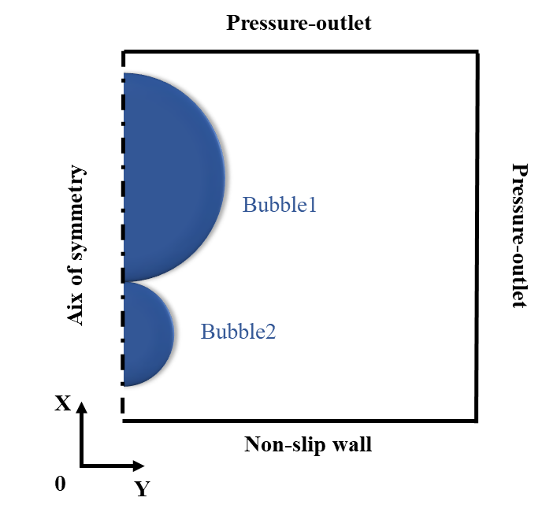

Fig. Sketch of simulation model.